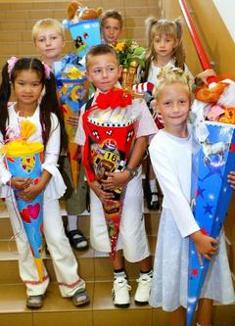
Every year in late summer, one can see the eager and proud faces of first-graders standing in front of their primary schools in Germany, happily holding their large Schultüten, or candy cones. Filled to the brim with sweets and little gifts and colorfully decorated with ribbons and crepe paper, these candy cones make the new students’ hearts beat faster and sweeten their step from kindergarten to primary school. But where did this charming custom of first-grade candy cones come from anyway?
The tradition dates back to 1810, when the first candy cones made the children’s eyes sparkle in Thuringia and Saxony. According to the legend, at the teacher’s home there stands a tree which is decorated with a candy cone for every child. Once the tree has matured, it is time to begin school and the candy cones are handed out to the children. In those days, the godparents gave the children the cone-shaped, colorful packages, which were filled only with sweets. In eastern Germany, the kindergarteners even had a candy cone party, at which the soon-to-be first-graders were promenaded before the families before being allowed to remove a candy cone from a beautifully decorated tree. Nowadays, candy cones can be bought in all shapes and sizes, decorated in a wide variety of patterns, and are filled with school materials, small trinkets, toys, and sweets.
A sweet beginning: These first-graders proudly display their Schultüten, or candy cones, which are filled with treats.
(© picture-alliance/ dpa)
On a typical first day of school in Germany, parents take their first-graders to the school, where they are welcomed by the teacher and meet their new classmates. After a small welcoming party with songs, poems, and theater, which most of the time are performed by the older children, the first-graders spend about two hours in the classroom, where they get to know each other and receive information from the teacher.
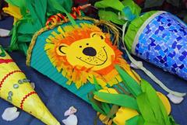
Once the first exciting day of school is over, the children are allowed to go home, where they finally unpack their candy cones and celebrate the start of school life with their families. And only a few years later, when they are about to finish primary school and look back at the photos from that special day, they will realize that they were hardly much bigger than their beloved candy cones, though they felt so grown up at the time.
Written by Denise Kotulla. Translation: German Embassy
Candy cones can be bought or made in various
sizes and decorated for each child individually.
(© picture-alliance / KPA/Aquila)

